Output to show mongodb queries:

1. Retrieve match information about team Argentina :

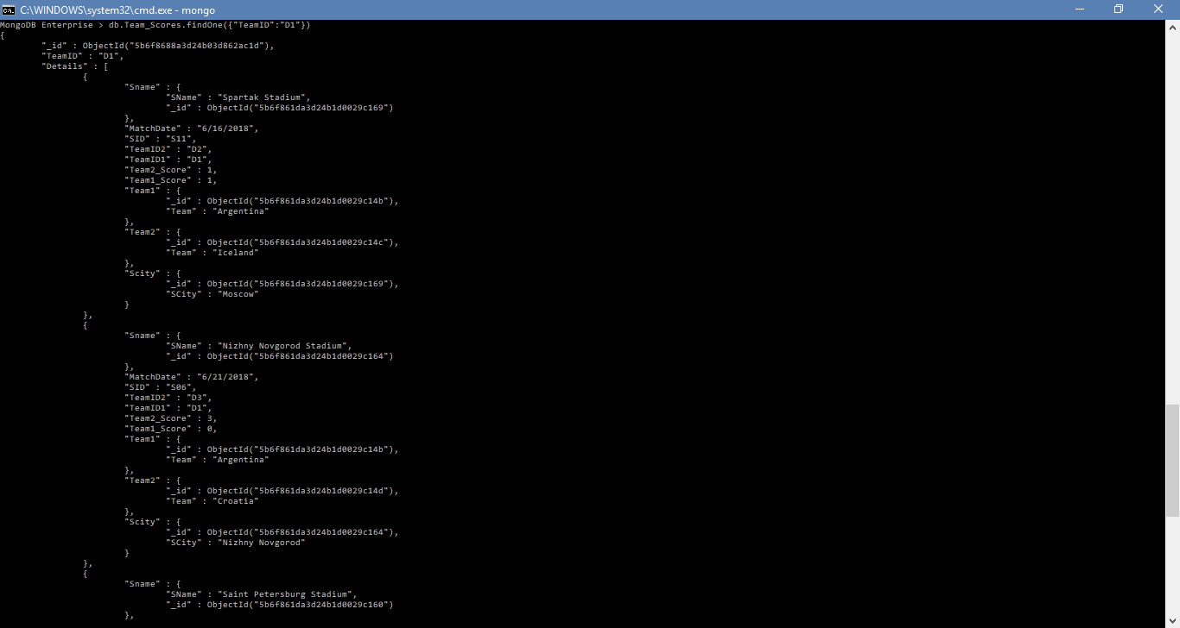

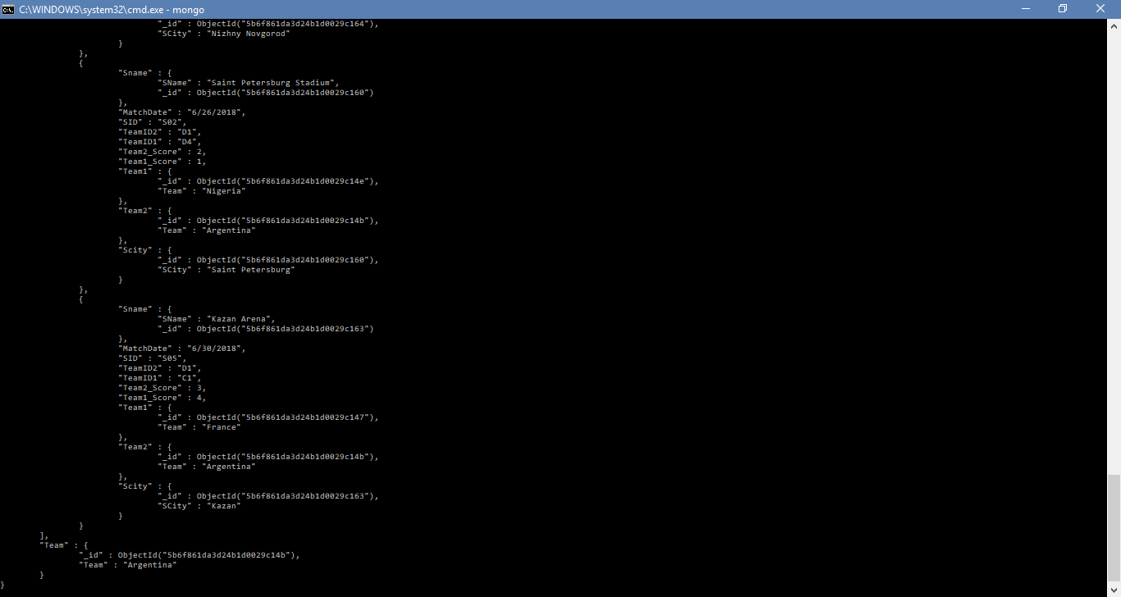

2. Retrive Information about team France



3. Retrieve information about "Lionel Messi"

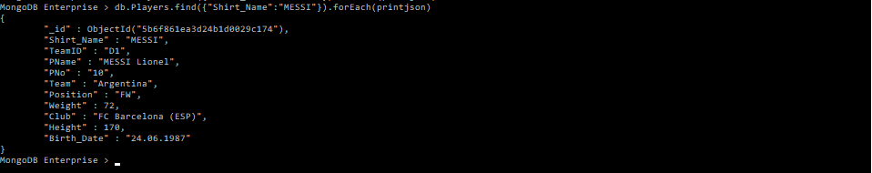

4. Retrieve information about Stadium "Luzniki Stadium"

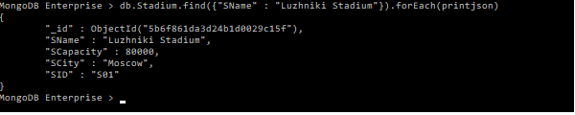

5. Query all South American Teams

